4.1 Footprinting & Reconnaissance (W2-PM1)
I performed reconnaissance against the networkwalks.com domain using six Kali Linux tools: WHOIS, WhatWeb, Nslookup, Curl, Wafw00f, and DNSRecon. Each tool was used to collect a different type of information about the target.
- WHOIS
I ran the whois networkwalks.com command to query the public domain registration record. The output revealed that the domain is registered with GoDaddy.com, LLC. It was created on 2019-11-06 and is set to expire on 2027-11-06. The name servers point to NS6135.HOSTGATOR.COM and NS6136.HOSTGATOR.COM.
Attacker perspective: This reveals the hosting provider (HostGator) and provides abuse contact emails (abuse@godaddy.com), which an attacker could use for social engineering.

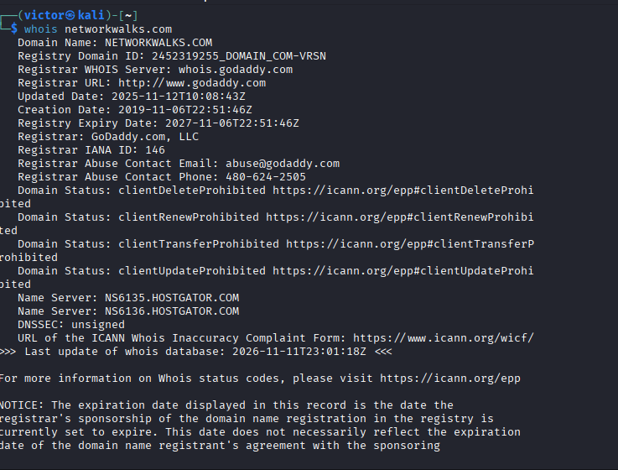

- WhatWeb
I used whatweb networkwalks.com to fingerprint the web technologies. The output identified that the site runs on an Apache server with a Bootstrap (7.1.4) framework. It also revealed the CMS is WordPress 7.1.4 and uses the plugin WP Download Manager 3.3.76. The server IP was identified as 192.232.216.135.
Attacker perspective: Exposing exact software versions allows an attacker to search vulnerability databases for known exploits specifically targeting WordPress 7.1.4 or WP Download Manager 3.3.76.

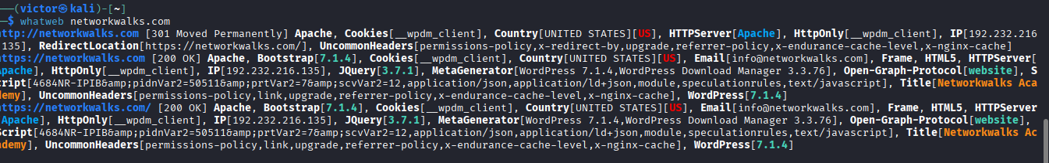
- Nslookup
I used nslookup networkwalks.com to resolve the domain name to its IP address. The non-authoritative answer returned the IP address 192.232.216.135 (using the Google DNS server 8.8.8.8).
Attacker perspective: Knowing the direct IP address allows an attacker to scan the server directly, bypassing the domain name, and potentially map other websites hosted on the same server.

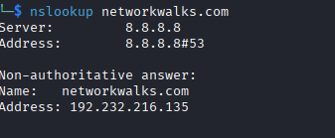

- Curl HTTP Headers
I ran curl -I https://networkwalks.com to inspect the HTTP response headers. The output returned an HTTP/2 200 status. It revealed the server is Apache, and exposed the Link header showing the WordPress REST API endpoint (/wp-json/).
Attacker perspective: HTTP headers leak the underlying web server and caching stacks. The exposed REST API endpoint (/wp-json/) is a common target for enumeration and potential vulnerabilities.

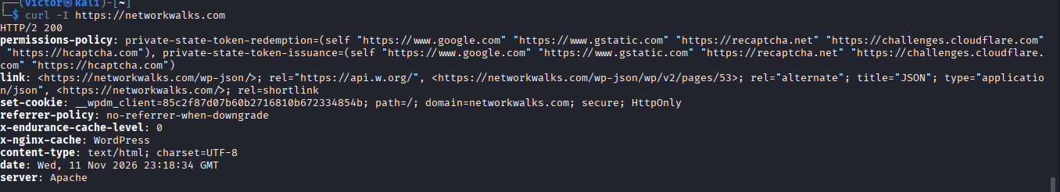
- Wafw00f
I used wafw00f networkwalks.com to detect if a Web Application Firewall was protecting the site. The tool confirmed that the site is behind ModSecurity (SpiderLabs) WAF.
Attacker perspective: Knowing a WAF is present is critical. It tells an attacker that basic or naive attacks will likely be blocked or logged, forcing them to find bypass techniques or adapt their attack strategy.

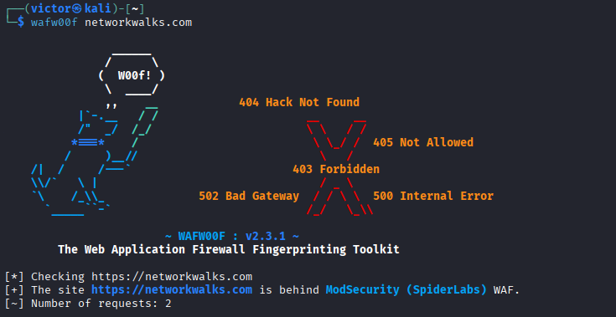

- DNSRecon
I used dnsrecon -d networkwalks.com to enumerate all DNS records. The scan returned 8 records found. It identified the mail server (MX mail.networkwalks.com), TXT records (including SPF policy and Google site verification), and multiple SRV records for cpanelmaildiscovery.cpanel.net. It also fingerprinted the DNS software version as BIND 9.16.23.
Attacker perspective: This maps the entire DNS footprint, helping an attacker understand the email setup, discover subdomains, and identify the specific DNS software version for potential exploitation.



